SDEV220 M01 - Setting up for Class (IDE and Jupyter Notebooks)

Instructions

### What To Turn In

* After completing/reading the above tutorial, create a Google or Word Document and paste screenshots of the following:
  + A screenshot of your Visual Studio Code program open and ready to go
  + A screenshot of the Jupyter Notebook program open and ready to go.

1. VSCodium on the left (instead of VScode)  
   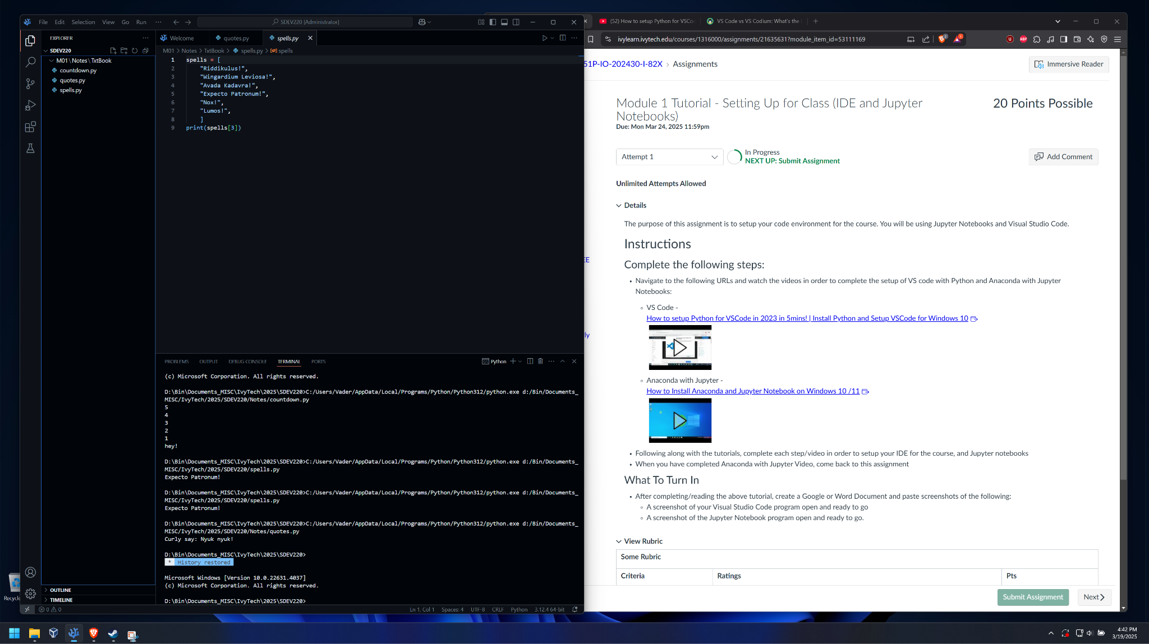
2. Anaconda + Jupyter Notebook  
   